**The Shield:**

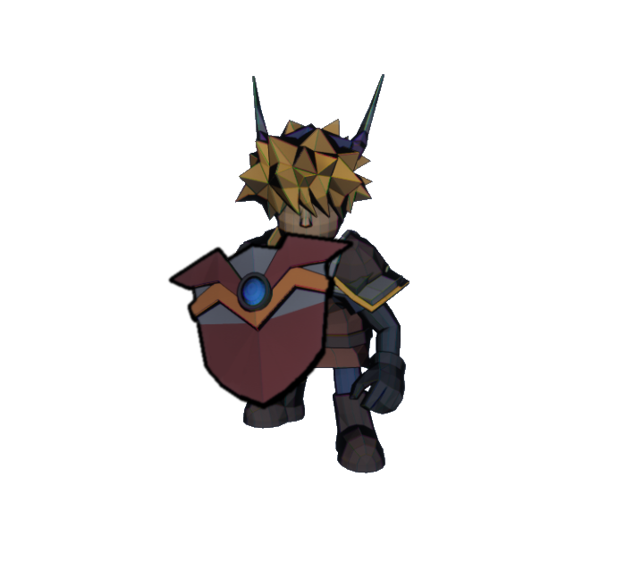

**Brief Synopsis**

The shield is a defence-based weapon used by the player character. The main draw for this weapon is its ability to keep the player from taking damage as well as packing large amounts of knockback with its attacks. That said the shield’s attacks will not deal any direct damage to enemies and act solely as a method for dealing with enemies in the players path or knocking enemies into hazards. In addition to this while equipped the shield will apply a minus 20% movement multiplier, slowing the player down.

**Usage**

**Block:**

This is a **Grounded** attack performed while the player is **Stationary** it holds the shield in front of the player and blocks any attacks coming from with a 180-degree arc in front of the player.

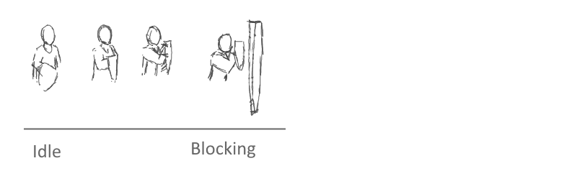

**Charging attack:**

This is a **Grounded** attack performed while the player is **Moving** it holds the shield in front of the player and charges forward this blocks any attacks coming from with a 180-degree arc in front of the player while also pushing any enemies that the player collides backwards and to the side.

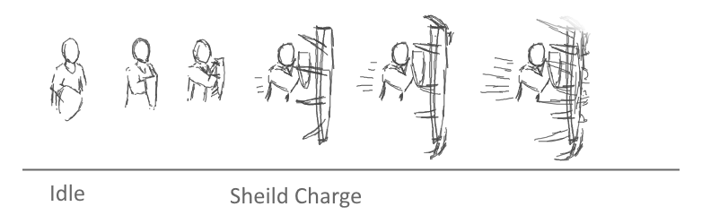

**Shockwave:**

This is an **Aerial** based attack that is performed while the player is attacking airborne. This attack has the player hit their shield with there offhand causing it to vibrate releasing and shockwave around them, this will push back any enemies within close range.

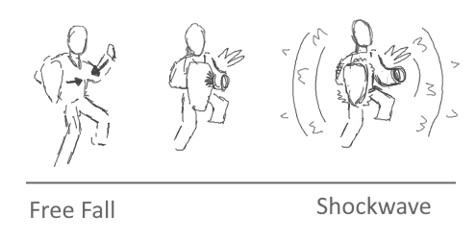

**Special Usage:**

**Shield Slide:**

This has the player jump onto the shield ad use it to slide down slopes or along rails. Like other special usages this can be done even while the shield is not equipped.

